Anatomy & Physiology

TOPICS:
ex. 36 respiratory anatomy
ex. 38 digestive anatomy
ex. 40 urinary anatomy
ex. 41 urinalysis
ex. 42 reproductive anatomy
ex. 43 meiosis/gametogenesis
ex. 44 development
ex. 45 genetics
Some review questions

1. Is the arrow identifying the internal OR the external urethral sphincter? Voluntary OR involuntary muscle? answer
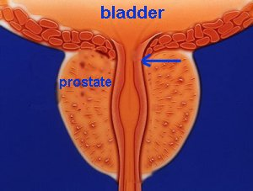
2. Name the labeled structures answer.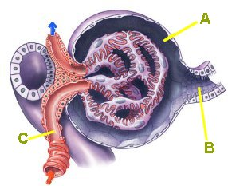
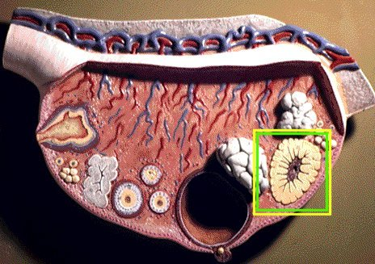3. Identify the boxed structue in the ovary,. What hormones are produced? answer
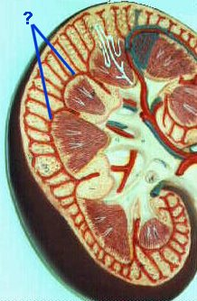4. Name the blood vessels answer.
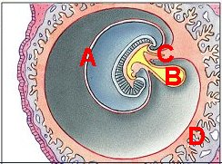5. Identify the fetal membranes. answer
6. Name the blood vessel. answer. 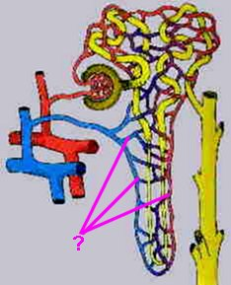
7. The labeled cell is a:
a. spermatid b. primary spermatocyte c.secoondary spermatocyte d.secondary oogonium e.primary oogonium answer
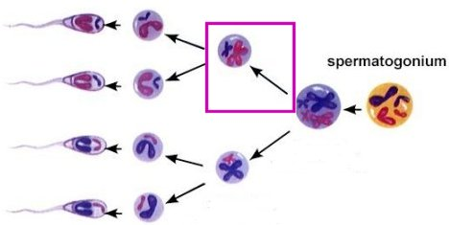

8. Name the hormone-secreting structure seen on answer100X.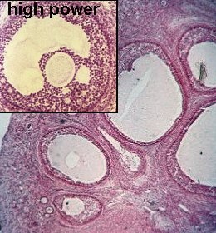
9. Identify the structures. answer 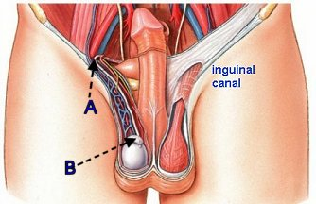
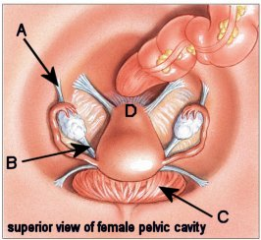
10. Name the ligaments labeled at A and B. Name the organ at C. Name the part of the uterus at D. answer
11. Name the labeled phase of the menstrual cycle. What happens at the blue line? answer.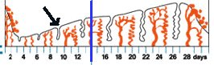
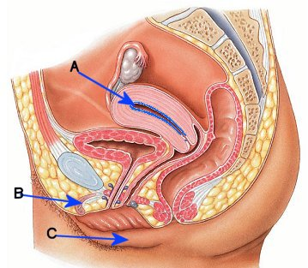12. Name the uterine WALL LAYER at A. Name B and C. answer
13. Name an organ or tissue that develops from the ectoderm germ layer. answer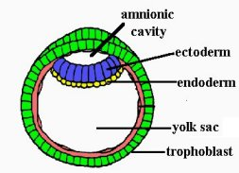
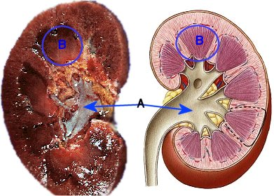14. Name area A, structure B of kidney.. answer
15. Name the stage of this fertilized egg, seen at 100X. Where would it be in the female reproductive tract? 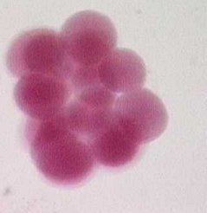
16. Name A (blood vessel), B, and organ C answer. 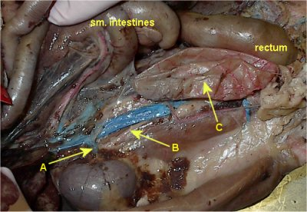
17. ID the organ inside of box and labeled structure. answer 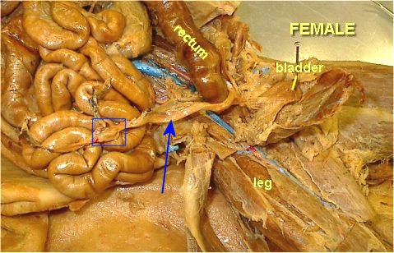
18.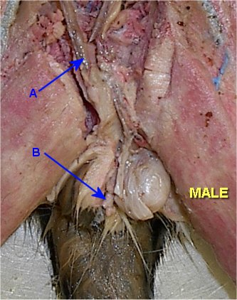 18. Name structure A, and end of penis at B.
19.Name the blood vessels inside of this and the number of each kind. answer 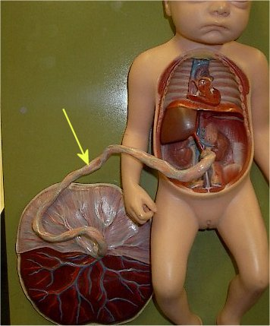
20. Which blood vessel carries oxygenated blood from the placenta to the fetal circulation?

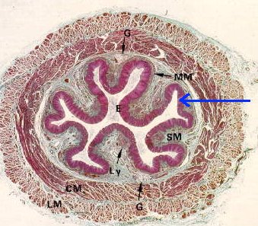21. Name the organ and the wall layer. answer
22. Name the organ and the wall layer (labeled with ?) answer 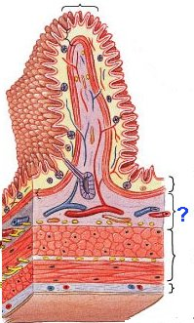
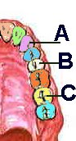23. Name the teeth. answer

24. Name the bone at A. Name the cartilage at B answer. 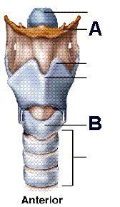
25. Name structure A. Name pouch-like structures labeled at B. Name this part of colon at C. answer
Name the sphincter at D.
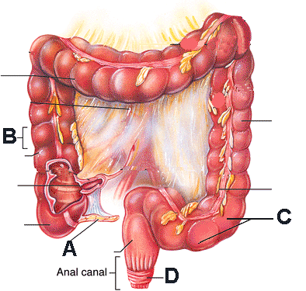

26. Name the organ that you see here on 43X. ID the specific kind of tissue comprising this organ answer .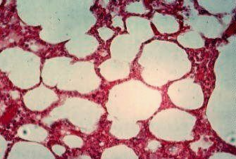
27. These are acinar cells---in WHAT ORGAN? 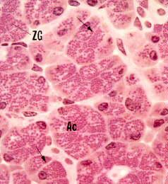

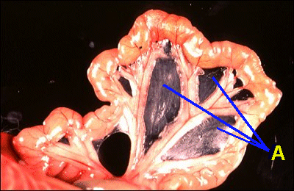28. Name this membrane labeled at A. answer
29. Name the labeled tooth answer.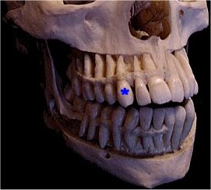
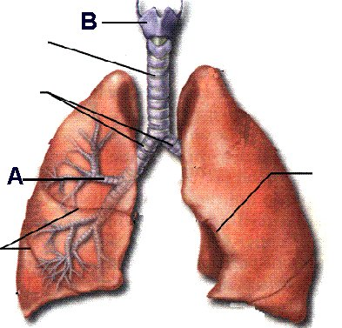30. Name airway at A. Name cartilage B. answer
31. Name the labeled sinus answer.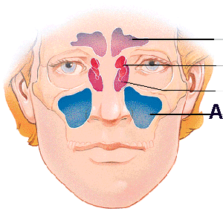
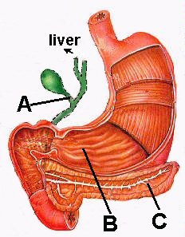32. Name bile vessel at A, REGION of stomach at B, organ at C. answer
33. Name the organs at A and B. 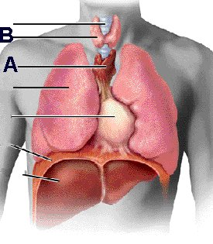
34. Name the structure at A. answer
Name the tonsil at B.
Where does the opening at C lead to?
Name this region of the throat. answer
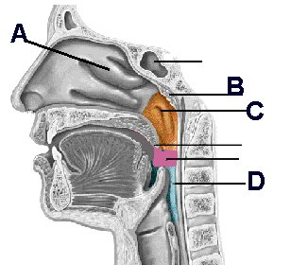
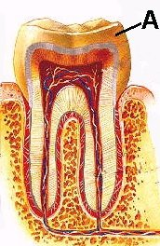35. This outer tissue labeled at A is called ____. The visible portion above the gumline is called the ________. answer
36. Name an organ having this specific kind of tissue. answer 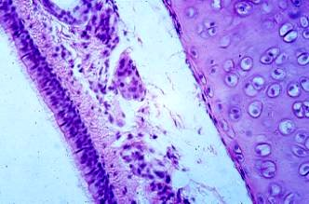

37. Identify the cartilage at the end of the arrow. answer
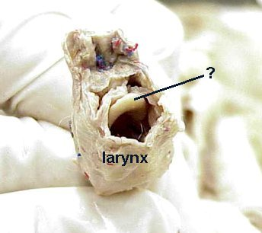

ANSWERS

1. internal urethral sphincter, involuntary muscle
2. A = Bowman's capsule, B = PCT, C = afferent arteriole
3. corpus luteum, estrogen & progesterone
4. arcuate
5. A=amnion, B=yolk, C=allantois, D=chorion
6. peritubular capillary
7. secoondary spermatocyte
8. Graafian follicle
9. A= epididymis, B= vas deferens
10. A = suspensory, B = ovarium, C= bladder, D = cervix
11. proliferative phase, ovulation
12. A=endometrium, B=clitoris , C = labia majorum
13. nervous tissue (brain, spinal cord), skin and accesory organs
14. A=pelvist, B=pyramid
15. morula, in fallopian tube
16. A = renal vein , B = ureter, C = urinary bladder
17. ovary, uterine horn (answer)
18. spermatic cord, glans penis
19. 2 umbilical arteries, 1 umbilical vein
20. umbilical vein
21. small intestine, goblet cells
22. simple columnar epithelium, example= esophagus, stomach, small intestine, large intestine
23. A=cuspid, B=bicuspid, C=molar
24. A=hyoid, B=cricoid
25. A=appendix, B=haustra, C=sigmoid colon, D=external anal sphincter
26. lung, simple squamous epithelium
27. pancreas
28. mesentery
29. cuspid
30. A=secondary bronchus, B=thyroid
31. maxillary
32. A=cystic duct, B=pylorus, C=pancreas
33. A=thymus, B=thyroid
34. A=concha, B=pharyngeal tonsil (adenoid), C=Eustachian tube into middle ear, D=laryngopharynx
35. enamel, crown
36. This is a shot of the trachea , showing pseudostratified ciliated columnar epith., as well as hyaline cartilage.
37. epiglottis

